DELICIOUSLY NUTRITIOUS
JANUARY COOKING CLASSES

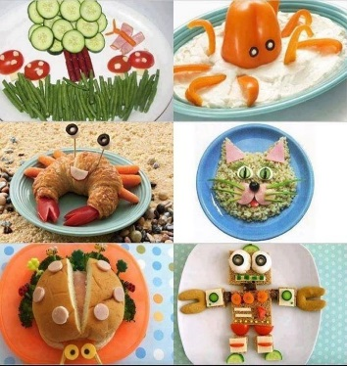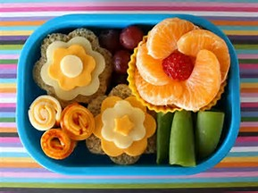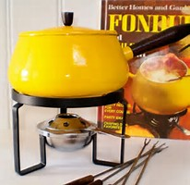

January 10th Japanese Bento Boxes
We are learning about and preparing a Japanese Bento Box (lunch box). Children will use their creativity and artistic skills to create a one of a kind bento box to carry home. Lessons in Japanese cuisine, packing a healthy lunch and food art.
January 17th Retro Fondue Party
We're going retro for this fun 1970's themed fondue party. Dip, Dunk and Eat some more, a delicious class is what’s in store! On the menu, cheese, chocolate and cupcake fondues.
January 24th Finger Foods & Fun Appetizers
It's ok to play with your food. In this yummy class we will be making fun and healthy child friendly finger foods that every student will absolutely love. This class is a great way to expand your child's mind and palate to the wonderful world of food.
January 31st Cupcake Decorating- We're making dessert the main event of this sweet treat themed class. Students will learn how to decorate their own cupcakes that they will bring home to share with the family.

Classes this month (January) will be held on Tuesdays from 3:45-5:00 pm. Parents are required to pick up their students at 5 p.m. SACC students will be taken to SACC after class.

Class packages are $75.00 for all four classes. Please make checks payable to DES PTO.

For more information please contact Melissa Sherwood at 410-533-1182 or delishdish4@yahoo.com

DELICIOUSLY NUTRITIOUS
JANUARY COOKING CLASSES - REGISTRATION

To register your child, send the form below in with payment to school. For questions please contact Melissa Sherwood @ 410-533-1182. Checks should be made out to DES PTO.

I give my son/daughter __________________________ permission to participate in the January afterschool cooking workshops.
Total paid $________________

Student Name: ____________________________________________________

Grade: ________ Homeroom Teacher: ________________________________

People Authorized to pick up: ________________________________________

Contact phone number: _____________________________________________

SACC: Yes______ No_______

Email address: _____________________________________________________

Any additional information that is helpful for me to know about your child: i.e. health issues, allergies, learning styles, etc….

~~~~~~~~~~~~~~~~~~~~~~~~~~~~~~~~~~~~~~~~~~~~~~~~~~~~~~~~~~~~~~~~~~~NOTE: These workshops are not designed for children with food allergies, as we will be using items that may contain nuts, wheat, dairy and eggs. If you would like to schedule a private allergen free class please contact Melissa Sherwood @ 410-533-1182.

