FAITH IN THE FLAKES
T-SHIRT ORDER FORM

DES personalized Faith in the Flakes t-shirts for $10 a piece. These shirts have a checklist on the back so that we all remember how to get those flakes falling when we are looking for a day off. Return this form and your payment (cash or checks payable to DES PTO) to school by Wednesday, January 4th. We cannot order t-shirts after that date. Get one for the whole family, so everyone can show their “Faith in the Flakes.” Order forms should be sent to the attention of Amy Schropp.

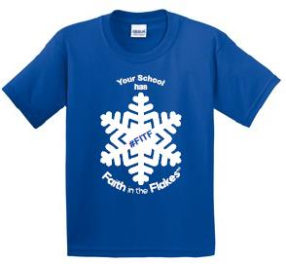

STUDENT’S NAME: ___________________________________ TEACHER/GRADE: ___________

PHONE: _____________________________ EMAIL: ___________________________________

Size | Quantity | Subtotal
YS
YM
YL
YXL
Adult S
Adult M
Adult L
Adult XL
Adult XXL ($12)
Adult XXXL ($14)

Total Number of Shirts _____________________
Total Amount Enclosed _____________________

Please make checks payable to DES PTO

