Advanced Learner Programs (ALPs) Parent Showcase
South River Cluster

Come learn more about opportunities for
Advanced and Gifted learners in
AACPS

Tuesday, May 8, 6:30-7:30 PM
Central Middle School
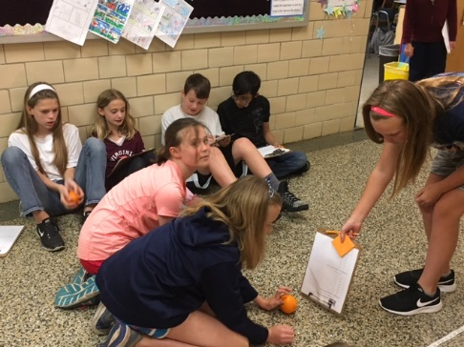

*This event is intended for all parents who
want to know more about Advanced Learner
Programs in grades 3-8.

To register, please visit https://goo.gl/forms/VmTLKWiSqMiEBsd93
*For more information, contact Don Counts, Coordinator of Advanced Learning PreK-12, dcounts@aacps.org

